Chapter 3, Problem 40.

For the bridge network in Fig. 3.86, find i_{o} using mesh analysis.

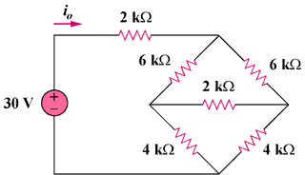
56 V

Figure 3.86
For Prob. 3.40.

